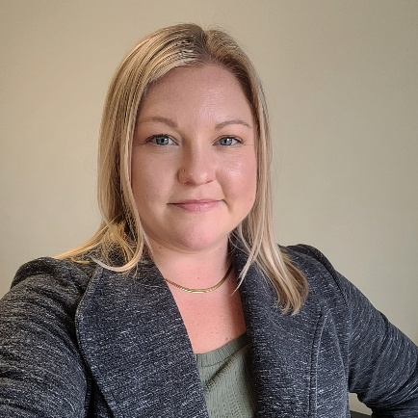
Amanda Mahan, MA
amandam@affinity-strategies.com
207-779-6070 (cell)

A Senior Executive Director (ED) at Affinity Strategies, Amanda currently serves as ED for three clients: American College of Osteopathic Emergency Physicians (ACOEP), Maine Osteopathic Association (MOA) and most recently American Society of Medical Association Counsel® (ASMAC). Amanda’s association management experience spans nearly a decade. Prior to joining Affinity in 2025, she served in various capacities with the MOA since joining the team in 2016.

Nationally, Amanda is the President of the Association of Osteopathic State Executive Directors (AOSED), and represents AOSED on several AOA Bureaus, Councils and Committees including the Strategic Planning Committee, and Bureau of Affiliate Relations.

Prior to her nonprofit work, Amanda gained experience planning corporate and private events at several Maine events companies and resorts. She attended the University of Maine where she earned a BA in Communication and continued her studies to earn a Master’s in Communication while teaching introductory courses as a Teaching Assistant.

Outside of her nonprofit leadership work, Amanda enjoys travel (and dabbles in travel advising) weddings and events, (as a recovering wedding planner) and enjoying the little things – a good book, a weekend hike, a delicious meal with a view. A lifelong Mainer, Amanda lives in Topsham with her husband and their Black Lab, Dill.

